**WEB CLASS 3: Moon Energy & It’s Importance In Our Lives**

**How To Work With It Towards Self-realization**

**A. Channelling Isis**

Hello my friends and family, this is Isis

Welcome to the gathering of light.

When 2 or more people are gathered in a place and energy is created. This monthly gathering u are doing:

1. u are creating a grid of light
2. u are bringing people together thru the light

And we thank u for this.

U are all very well aware of the light.

The fight between the light and the dark has intensified.

But light will always win, know that.

Some of u have seen challenges in these last few months of yr lives.

** **We want all of u to pay particular attention to these coming summer months.**

**Why?**

i. Many planets will be going retrograde.

ii. It can cause much thrive in one’s life

iii. An energy of destabilization can happen

Like a wise person who prepares for the calamity.

If u prepare yr energy from right now.

U will be able to handle the summer months with ease and grace.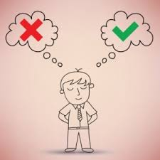

During these months people will feel very edgy.

When they are on the edge their survival instincts kicks in.

So they will try to survive thru their words and physical actions.

So who is right n who is wrong becomes very important for them.

**WORKING WITH THE ENERGY OF THE MOON**

But if u were to work with the energy of the moon, it can support u. But it’s a double edged sword.When the **moon shines it’s brightest**, like today a **great creative energy is unleashed.**

**But how do u use this creative energy, that is the question?**

In some of the major cities in the world, the Police and Justice Department know about this and they have extra police patrol on the roads.

The full moon:

* **affects** the human emotions.
* **affects** the **organs** in the bodies especially the **Endocrine System.**

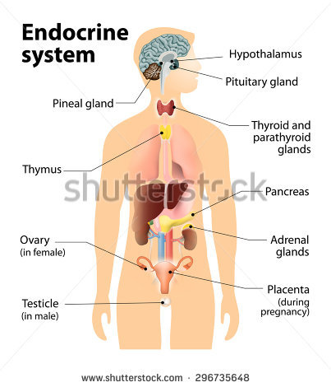

**PURPOSE OF THE MOON ENERGY**

**What is the purpose of the moon energy?**

1. **Creation**

**What does this mean- CREATION?**

Moon’s energy supports all creatures that support Mother Earth.

**What does that mean?**

In all the water waves of the World like oceans, rivers and lakes there are organisms, bacteria living underneath. And they keep:

* the water currents running.
* they help in the flow of water
* and also the regeneration of water.
* **Regeneration and reproduction**

But the organisms need light to reproduce. So during the full moon time - the moon’s rays can penetrate deep down into the ocean’s floor and regenerate this energy so that these bacterias can reproduce using the light from the moon.

This is why many people who are tuned in to the energy of the full moon become very creative during this time.

* **Programme the internal organs**

During this time all yr internal organs are very alert.

You can **program yr organs** at this particular time **using the energy of the moon**.

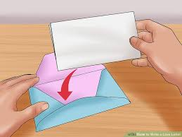

* **Setting Intentions.**

U may also want to create intentions during this time period.

1. Write down the intention of what u want to create,
2. put it in an envelope.
3. Keep it for the the moon’s ray to fall on it.
4. Then work with the moon energy after it’s over till the next cycle of the full moon.

U will energize yr intention of creativity. U will see that the manifestation of yr intention can happen much more quickly this time.

2. **Influences the blood**

* **Stimulates greater growth and harmony**

Secondly since u are a water being and as the moon can influence the water, the blood in us can be stimulated during this time. This is the process u must undertake if u can during the full moon time to **spend time under the full moon** so that the water, the **blood inside u can be stimulated** once again for greater growth and harmony.

* **Releases imprints**

This is because the thoughts affect the water which is the blood inside of u. The blood carries these imprints to all the organs in yr body.

Since yr heart is the pumping machine in which the flow of blood comes and goes back into the heart, the imprints which in the blood goes into the heart and gets embedded in the heart. This is why when there is stimulation of the water within u during the full moon time, u will be able to **release a lot of these imprints** which u **accumulated during the past one month.**

* **Become conscious of the God Presence within**

Yr blood contains much more than what you think or what the scientists know.

In its purest essence it carries the very life essence of God itself. So when u are conscious of yr blood, u are conscious of the God presence within u.

* **Nourishment**

**What produces the blood?**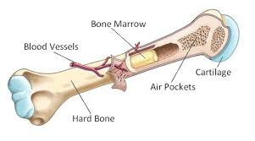

The bone marrow produces the blood.

**What does yr bone marrow contain?**

It contains the very elements and Gaia.

**Who nourishes Gaia n the elements?**

The moon and the sun nourish Gaia.

* **Shift patterns and frequencies**

See the importance of the moon!

Communicate with the spirit and work with the blood cells, the bone marrow.

And u will see that u are able to shift certain patterns and frequencies.

3. **Releasing of fears**

U have been told about the sacred geometry patterns that exists in the human body.

but more than the sacred geometry patterns, there are certain codes implanted into u.

And one of the codes that has been implanted in u to keep u in darkness is the:

* **CODE OF CRUCIFICATION.**

**What does it mean?**

This **code represents the deep subconscious programming** that u have to **suffer to feel the love of God** within u.

And religion was built on this premise.

We encourage u today to release these imprints within yr bone marrow.

All who are here today carry some imprints of this programming in them.

The second code or imprint which has been programmed into yr bones is the :

* **Misunderstanding of the number 666**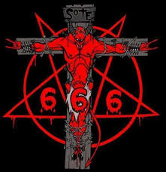

When u see this number, what is the first impression that comes to yr mind?

It’s an evil number, number of the devil - Is it not?

But if u were to look at 666

* it’s the most sacred number.
* the 6 represents the 6th layer of the DNA which represents the I AM PRESENCE within the human being.
* it represents the 3 parts within u

|  |  |  |
| --- | --- | --- |
| The Son | Athma | Soul |
| The Father | Paramathma | Monad |
| The Holy Ghost | Mahatma | I AM PRESENCE |

* again if u add up 666 = 18 = 9

**And what does 9 represent?**

A fully realized spirit in a physical body, living the truth of the spirit

This has been deeply programmed in u so that u don't realize. They have put fear in u.

*** **ASK FOR IT TO BE REMOVED**

* **Aversion to snakes**

The third fear which has been programmed into human beings is the understanding of snakes. Most of us have an aversion to snakes. but u all know that the snake represents the Kundalini Energy.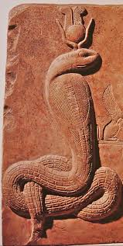

People who have been to Egypt, they found descriptions of snakes everywhere. In many of the Hindu temples, u will see the carving of the snakes. U will find the great God of India, Lord vishnu lying down with a serpent. But human beings are afraid of snakes. Again this is a fear programmed into a human being.

Now all these 3 fears are heightened during the full moon time.

Yr senses become more alive during this time.

So these 3 fears are increased in yr subconscious mind during the full moon time.

This is why during the ancient ones in India and other cultures there are ceremonies during the full moon time.

In Bali, there is a special ceremony during this time. In Egypt there is a ceremony.

** **WE ASK U TODAY TO RELEASE THE IMPRINTS OF ALL THESE 3 WITHIN YR BEING.**

But it has been programmed so deeply into many generations within yr being. **It will take some time to work with it.**

4. **Get in touch with natural water**

Now I(ISIS) ask u during the full moon time get in touch with the natural water.

* **Meditate with a glass of water**

Ask the energy of the moon to be anchored in the water.

Drink this water.

* This is especially for people who are sad or depressed.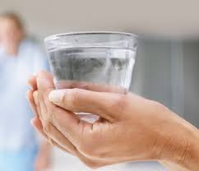
* Also good for people who are stuck and looking for a solution in their lives.

5. **Hand Gestures to connect with the energies of the full moon**.

Hand gestures to support u to **connect with the energy of the moon** during full moon time. It is best done in a bath tub or when the body is wet.

i. Extend yr right hand fully

ii. And open yr right palm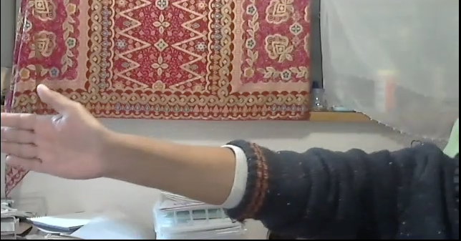

iii. Close yr eyes.

iv. Make the sound- it’s an ancient chant for the moon.

(chant along with me-54.35)

EE HAY YAH

LAA OO MEE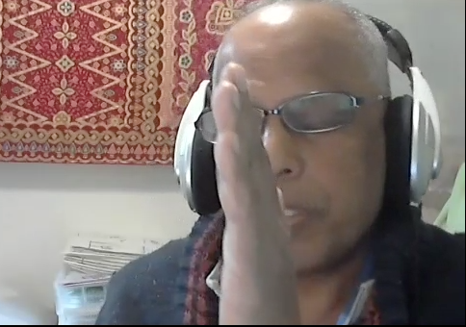

U will start feeling energy in yr right palms.

When u feel the energy in yr right palms

Bring yr left hand like this



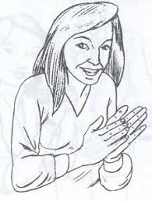

Then rub and slide yr right hand up the left hand

and vice versa

Chant

EE HAY YAH

LAA OO MEE

Again u will feel energy in yr forehead

Do 9 X

When u complete the 9x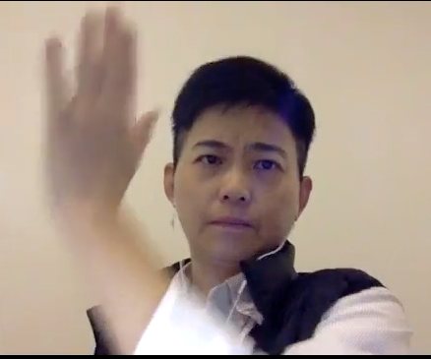

Do the same to yr right side

9x

Chant :

EE HAY YAH

LAA OO MEE

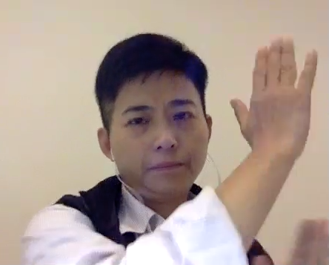

Then to yr left

9x

Chant:

EE HAY YAH

LAA OO MEE

Then be in the energy for a moment.

U will feel energy coming and settling in

Some of u might feel some slight pressure on yr forehead.

Some of u might feel energy coming from the top and going into yr forehead area and slowly coming down into yr body.

This exercise is to connect with the energy of the moon and to encompass and fully integrate yr energy with her energy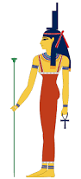

This is Isis.

**B. Channeling the Moon**

Hello my family, I am the Moon

Do u know when one is born, my energy is with every **child especially on the crown chakra area.**

**If u were to ask where is the energy of the moon in the physical body?**

There are 3 places.

**Crown Area**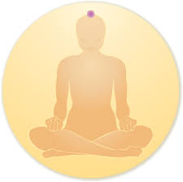

But one place where it is **most concentrated** form of my energy is on the **crown chakra** area.

If u were to bring yr attention to that part of yr body right now.

Chant slowly ( *he didn't say the chant* )

Breathe from that part

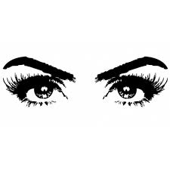

U will feel, u are pulling the energy and pushing it out thru both part of yr eyebrow area.

U will feel pressure on yr eyebrows.

Breathe into that again.

**What will it do?**

It will create a sensor for u.

When that is developed

The sensory perception will increase, it will **act as yr other eye.**

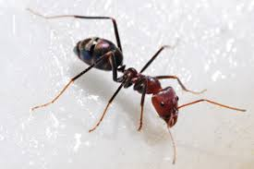

So like insects, that have antenna on their head like the ants, butterflies.

They use their antenna to find food and also to see if it is dangerous or not.

U will be able to use this sensor within u to know whether it is truthful or not

Yr sense of perception will be enhanced and u will start to understand how in nature the natural beings live especially the beings that crawl on the on the grounds- bugs n beetles. They live by **sensing the truth all the time**. Yr life will be different.

**Both the Ears**

Now u have more sensors than these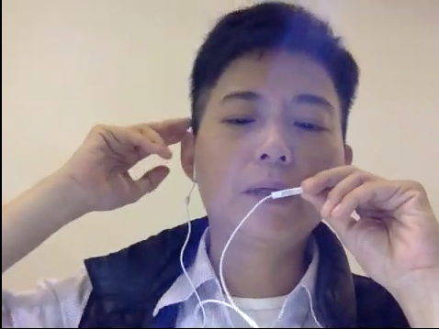

U have 2 sensors coming out from the top of each ears.

So all in there are 4 sensors on the top of yr ears.

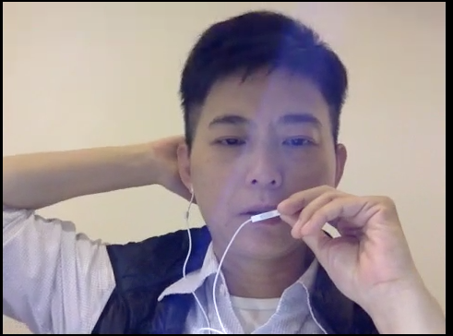

And u have 2 more at the back of the head on the skull area

Focus on those areas

And we would like u to make this sound:

Terra Terra Terra Terra Om

Terra Terra Terra Terra Om

Terra Terra Terra Terra Om

Mai Mai Mai Mai Mai

Mai Mai Mai Mai Mai

Mai Mai Mai Mai Mai

Shung Shung Shung Shung Shung

Shung Shung Shung Shung Shung

If u observe carefully u will see that yr ears are perking up

It comes alive once again

Some of u might feel some slight pressure on yr ears.

**What is happening?**

Yr ears are being expanded.

In some of the cultures especially in the Far East, when a person is sleepy or very tired.

What do the elders do?

They take a small pin n prick the top of the ears. A slight blood might come.

Sometimes they just twist the ears.

In a matter of minutes the person will start feeling better.

Same way -when u do the sounds u are **activating the sensors** there.

Because-

1. in the ears there are DNAs
2. and also at the back of the ears there are 3 minor chakras

So when this is developed again yr sensory perceptions to hear long distance is enhanced.

**Why do we tell this to u?**

It is time to look at **all beings alive on the plane**t because they are all **participating on the Ascension process.**

They are bringing light and they are holding light.

And they have **messages to give to u**.

Each being has a truth.

U have to stop looking at them as creatures but as souls and an aspect of God itself.

**Healing the Water**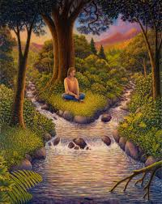

Now I ask u to do 1 other thing

I know all of you love Gaia.

Some of you are quite concerned about what is happening on the planet- the destruction

One area I want u to focus is the WATER.

Especially water that has been contained like a dam or a lake that doesn't flow.

As u know, water is very natural.

Water goes thru many processes before it comes up.

It goes thru deep sediments of oil, rocks and tree roots underground.

It **carries very high frequencies of light and wisdom**

But as u know, human beings rarely drink water coming out of the grounds.

It has been bottled and said to be natural water. Let me tell u , there is no natural water in the world now.

Now this **water** which is not flowing or **not allowed to flow** especially like a dam. The **life force energy** in the water is **depleted.** And the **water is very angry**. If u were to go near a dam and observe, and just walk around the dam, in around 10 minutes time yr body will start to not feel good. Some of u may feel sadness. Anger or grief will come in. U might ask what’s happening to me?- suddenly I am feeling very down. U are feeling the sadness, the anger or other energies of the water.

**Water all over the world is connected to each other**. Since the water is very upset being dammed up and since we are water beings, our water inside the body is affected.

Now there may be a little truth to why there has to be a dam.But we would say it can be done in some benevolent way then to dam up and not allowing the water to flow.

** We want u to **do the exercise as shown by Isis into the water** (refer to the No 5- hand gestures- channeling by Isis)

And u will see in a matter of minutes u will start feeling good. That means the water is feeling good. U will participate in healing the water around the world. This exercise given by Isis is ver simple but very powerful.

Any energy where there is water in it- u can do this exercise to bring healing to that water.

**Healing the Trees**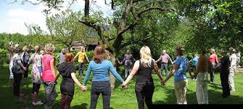

Some of u are interested in the trees.

Trees not only produce oxygen, they have a much bigger role to play.

Some of the ancient ones have pure natural energies. But because of where they are and the consciousness of where they are, they have been affected. So they are picking up energy from the ground. Since the **denseness of the place** is so heavy, they are **unable to emit their naturalness.**

We want you to **start healing the trees.**

Again this simple exercise:

If there are no trees, there will be no human beings.

They carry much more than what we know.

**What does the bark contain?**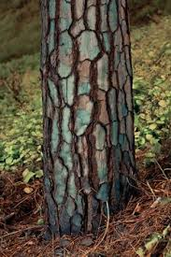

Dear ones, it **has history.**

Many of the medicines and **cures** for many sicknesses will come from trees, herbs and plants in the future. Including AIDS.

If u are interested, work with the tree barks and they have **secrets to share**.

If u were to just touch a tree bark with yr hand.

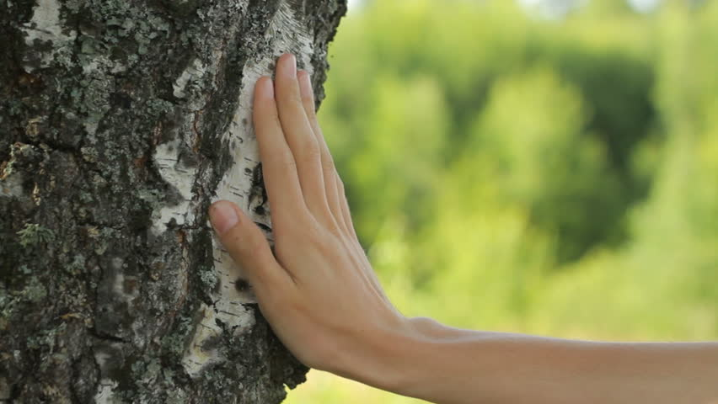

Open yr palms and just tap the tree

And say these words

Sa Ki Yu

Sa Ki Yu

Even now , close yr eyes

Imagine a big tree

Yr right hand is opened

Touch it!

Sa Ki Yu

Sa Ki Yu

Sa Ki Yu

U will feel energy in yr hands

And sometimes u might feel or see a small tree appearing in yr hands

In many of the mythology, u will see the gods and the trees.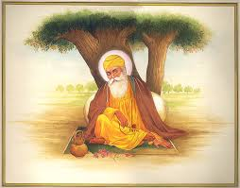

All Masters were under the tree-**Why?**

The trees pick up the energy of the moon.

And they hold it in the leaves, trunks and the barks.

**Why do u feel good when u go under a big tree?**

Not only because of the colour they are emitting, u will feel the energy of the moon.

**And what is the energy of the Moon?**

* Creation
* Nurturance
* Benevolence

So u want to feel me, come under the trees and be with me.

**Trees are like a storage bank**

Why do u think birds build their nest or rest on trees?

Because of the energy of the moon and the trees.

**Moon’s energy** n the trees energy **feeds creation**

Our energy can feed u.

Some of u if u are daring enough, I will give u some exercise

Go under the big tree, especially when there are not many people and not much light reflecting on the tree.

Touch the tree with yr right hand.

And breathe

Make this sound

And then ask that the chi or the energy of the moon it’s holding along with the tree’s own chi to be given to u.

Imagine this coming into u.

U will not feel hungry.

The sound is: Ki Hu Wa Shi

Ki Hu.. Wa Shi

That means: U will not feel hungry. Stomach will feel full, also can use it to lose weight

This is why Native people sang and danced during the full moon.

Partaking of this essence, this monad, this food n filling up their bodies with this.

This not only nourishes yr body but yr mind and soul

And finally

When people die- have u heard people say of the great white light, like a tube of white light?

U might have read this-that they are going thru a white tunnel.

What is this white tunnel?

It’s ME (moon) coming to greet u!

So I am there when u are born n I am there when u go.

U are part of ME!

We cannot be separated.

Remove this illusion from yr mind.

Close yr eyes,

Breathe

and simply say: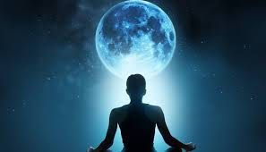

I AM ASKING AND GIVING INTENTION TO EXPERIENCE THE ENERGY OF THE MOON WITHIN ME NOW.

And just allow for this energy to go thru u. Allow it n stay in the moment

I Am the Spirit of the Moon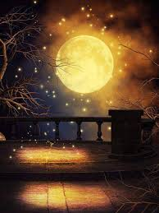

**C. Chanelling AA Gabrielle**

We have some parting words from AA Gabrielle

Blessings my brothers and sisters.

U are very honored to be able to speak to sister Isis and of course Gaian n Moon.

Like u all have yr own spiritual name, the **Moon** has her own **spiritual nam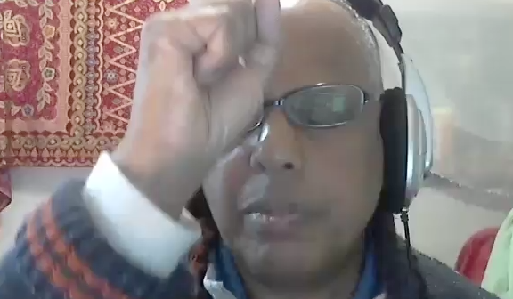e**.

It’s :

**LA BA NA HA**

When u call this name LA BA NA HA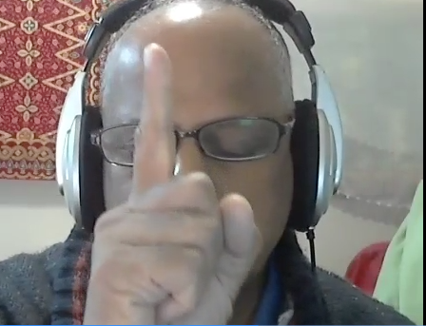

We ask u to open yr right hand index finger like this

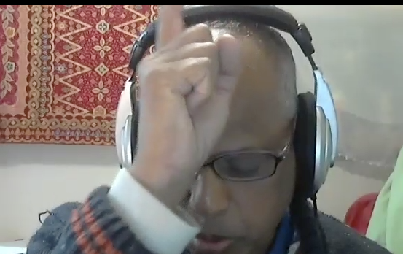

And bring it to this part just above yr forehead

Keep yr chin straight

Yr body straight

And say:

LA BA NA HA 9x

Stay in this moment

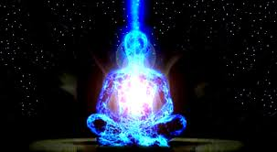

Again u feel strong energy in yr forehead.

Like an energy flow coming from above

As mentioned by the Moon spirt, u know that:

1. she is there when u were born
2. and also with u when u leave yr body.

iii. She nurtures u every moment of yr life.

It is time to start acknowledging her.

And she will share more of her love and wisdom with u.

And one of the ways is simply calling her name

LA BA NA HA

Using this hand gesture.

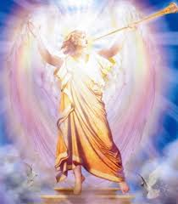

I AM AA Gabrielle

I bid u farewell this time

Enjoy the energy