**WEB CLASS 3: Questions & Answers**

Hi this is Isis.

Isis will take some questions.

**Question 1:**

Last month an exercise was given to heal the trees. We have another one this month. Are u saying we should do these 2 exercises to heal the trees?

There are many ways of healing the trees.

U can choose either one.

**Question 2:**

Can these exercises be done by anyone?

Today’s exercises are very simple.

Anyone can try these exercises and they will feel the energy.

Even those without any spiritual practice. They will feel the energy.

**Isis:**

When u become friends with water and the trees.

They will start revealing hidden secrets.

I give u a hint.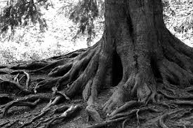

**What do the roots contain?**

Have u wondered?

Thru the roots u will be able to travel to other planets.

Work with the roots.

U will be amazed.

The roots are vehicles to travel

There is life force in them.

I encourage people who are channeling to channel roots.

The great teacher Maha Avatar Babaji, he talked about roots one time.

We encourage u to channel roots.

**Question 3:**

To clarify the position of the of the DNA on the ears.

Its on top of the ears- left and right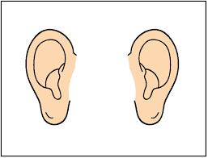

And 2 more at the back of the head.

**Question 4:**

Can we do the exercise for trees using the chant Sa Ki Yu with trees that are dying or dead?

It’s best now to do on a tree that is alive at this time.

U will feel more energy.

*“I would like to send energy to the drying tree”*

Yes, u can but many trees have lost their life force.

There is a lot of work to do because of the loss of life force.

But of course u can

But as u know the tree has its own life, it’s own spirit and it’s own DNA n blue print of life. Certain trees have been used to control people. To stop us from bringing in light.

So when u heal a tree u will feel very good.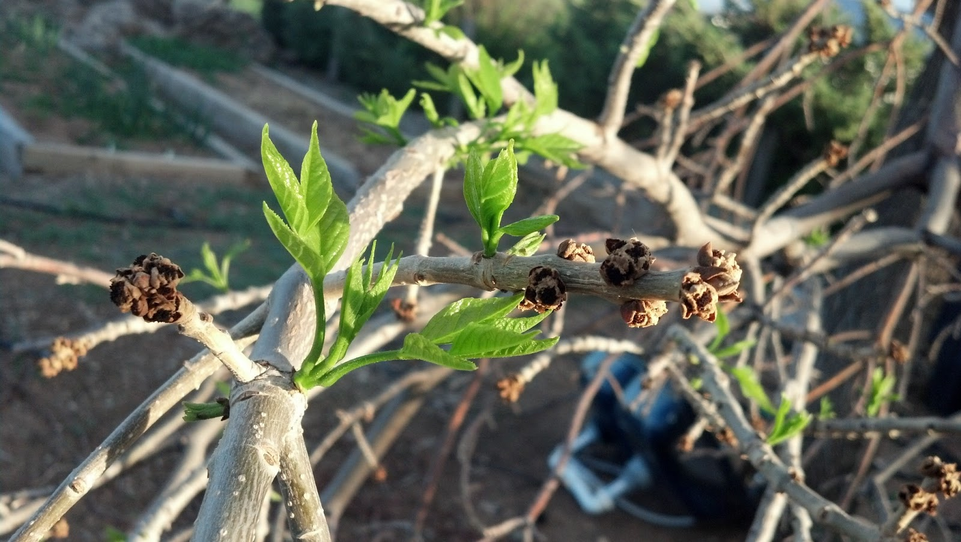

How do u know u have healed a tree?

It will start growing again.

Hello my friends, I am the **Elder of the Oak Tree**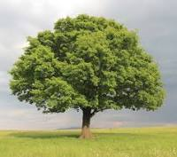

We need all the help

Look at yr world, people are destroying everything.

There is no respect for any form of life.

They don’t even respect human beings- they kill them.

Of course they don’t respect any trees or any other forms.

They believe we are below human beings.

Yes, we need love n light from human beings.

So that we can perfectly function once again

**Question 5:**

To write the intention and put in an envelope and start working on it till the next full moon. Is that what u said?

Yes.

Energize yr intentions using the energy of the full moon

*“U mentioned something about AIDS”*

Yes, many of the healing properties will come from plants and tree barks.

*“Anything for diabetes?”*

Yes, u will find cure from a particular plant.

I believe that plant is a particular wine.

Not to be revealed now exactly what wine

Now this is **Isis** once again.

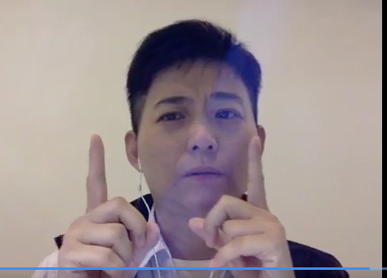

Now bring yr 2 hands like this.

In front of yr heart

And slowly chant

LA BA NA HA

Chant 3 x deeply

U will feel a lot of energy and a stillness coming into u

Both yr palms u will feel it tingling.

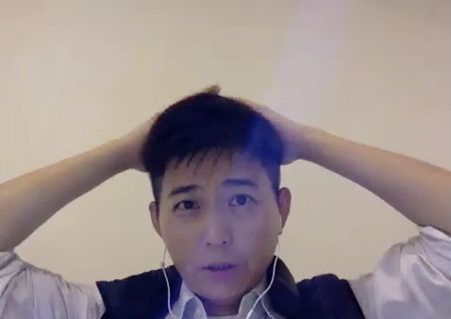

Now bring both yr hands and touch yr crown chakra area

And chant

LA BA NA HA 3 x

When u do this u will feel expansion.

What are u doing?

U are connecting with the expansive energy of the moon and the moon is connected to more than 144 planets.

Thru this sound and thru the expansion, u may be able to tap into many higher dimension planets.

Be **AWARE** u will be taken to other realities.

So don’t over do it.

But if u **need solutions to yr problems in yr life**

Work with this expansion energy.

Because LA BA NA HA supports creation that’s coming from the very source within u.

We will disclose one very **important** thing.

People who have problem with **drinking** and are not able to stop drinking.

Work with the energy of LA BA NA HA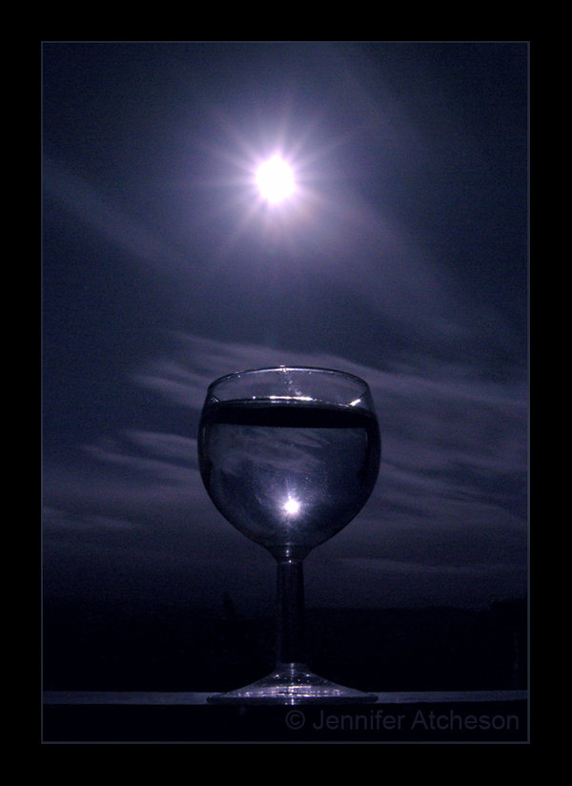

Place a glass of water outside

And let the energy of the moon come into the plain water

And let the person who drinks, drink this water.

U will see in around 3 to 4 weeks time

He will lose interest in alcohol because he won’t like the taste any more.

Do u know who likes it very much?

The **Cats**- they know about us very well.

They **communicate** to us.

If u really look into a cat’s eye, What do u see?

U will be taken to a different reality.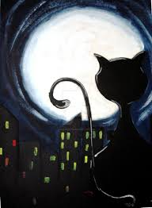

Why do u think cats go out in the night?

People think they are looking for mates, to fight or just to make sound

They are having council meeting outside.

They are **talking to me n the elders.**

For I am their Guide.

I am the guide for all animal kingdom.

Why do u think animals are more awake during night time?

To connect with me

For I am the nurturing mother for all.

**Question 6:**

Can we use the sound Sa Ki Yu to heal the trees remotely?

Yes, u can.

But u need to build up energy to do it.

**Isis**

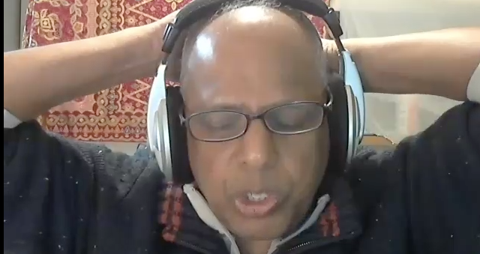

This exercise placing yr hands on the crown chakra and chanting

LA BA NA HA

It is for advanced spiritual work and not for beginners.

U will feel expansion very quickly.

So work with it with caution.

This is more advanced spiritual work.

People who take medicines

Place the tablets in yr hand

Go outside or be in a place where moonlight is coming

And hold the pills in yr hands in the moonlight for 3 minutes.

U will see u the intake of the medicine becoming lesser in the coming days.

The medicine will become very effective so u do not need to continue for a long time.

**Question 7:**

Are we going to hold the medicine just once or every full moon?

Full moon doesn’t happen every day, but the moon still exists.

U hold the medicine in yr hand and call for the energy of the moon to come n u will feel the energy of the moon in yr hand , in yr medicine. u take that medicine. Maybe u want to charge 12 and take some everyday. U will see a difference.

**Question 8:**

Do we just hold the medicine or chant as well?

U can call on LA BA NA HA.

**Question 9:**

Can it be used for any other addictions like smoking?

Right now its only for alcohol. The addiction of smoking is for a different purpose. Alcohol has water content in it.

**Question 10:**

How do we balance ourselves if we have too much moon energy?

Important question to ask. Dear one, it is true sometimes the energy of the moon can stagger us- a little bit spaced out.

So we encourage you to work with LA BA NA HA for not more than 20 minutes.

It can upset many organs in the body.

The blood can be stimulated too much, restless, irritated, angry n a feeling of not well. This is because u have stimulated too much.

So initially work for **not more than 20 minutes for 3 months.**

But also during this time-placing or holding **gold** on the physical body.

This can support the higher integration of light.

**Isis**

But what we encourage u to experiment for the next few days is:

Place a glass of water, even tonight for about 20-30 minutes.

Then drink that water.

U will feel a difference.

Especially people who are out of the hospital-recuperating.

Healing takes place much, much faster.

Very good for people after operations,



If u really study u will realize many people pass away during the full moon or just after the full moon. Have u observed that?

Why?

They are at a much more peaceful state after the full moon appears. So u can check this out- more people die during the full moon or just after the first few days of the moon. They have more peace in their hearts.

**Question 11:**

To clarify the water that has been kept out in the moonlight, can it be kept for few days b4 giving it out to people?

Yes, u can.

But it requires a longer period of time outside maybe overnight and protecting the energy.

**Isis**

How do u drink this water?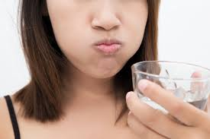

U take the water in yr mouth.

Don”t swallow it for the time being.

Hold it in yr mouth

And circulate it in yr mouth.

Try to hold the water for 30 to 60 secs.

Even now if u have a glass of water

U chant a prayer into the water

Drink that water.

The water in yr mouth will be amplified with the energy of God, the water will affect yr tongue and this will affect yr pineal gland.

Just a sip of water n hold it in yr mouth for 60 secs

And mentally say a prayer into the water- a short one a word or a line.

U will feel energy filling in yr mouth and expansion going thru yr throat, skull, pineal gland and then shooting upwards.

Especially the energy of the water after programming it with LA BA NA HA

Do not gulp it. Sip it slowly - keeping it for 30 to 60 secs. The benefits will be much more enormous.

**Question 12:**

Just to clarify , do we set an intention for each recipient who is going to receive the water?

No, its like a general charging. Then can give to those who have problems.

Just drink.

Beneficial for those with problems in their mouth area.

**Question 13:**

What can we do to replenish the water in dry areas?

An important question.

U must work with the roots of the trees.

U can call on me -LA BA NA HA

But there is also a water master.

There is a being who is in charge of the water element in the planet.

This Being is not in this particular reality.

And ancient Mayans knew about this Being and conferred with him during ceremonies.

Call on this being.

More than replenishing, what is important to look at is that there are much more pure water in the underground deep down the Earth. Huge reservoirs of pure clean water.

Bring that out. U will see one of the problems in the future is the allocation of drinking water in the world. Sometimes there can be conflict for water. there is so much water underground, deep, deep in the Earth. Pure clean water. it can be brought forward.

U work with LA BA NA HA

Meditate and call the water Spirit ( will tell u the name later)

**Isis**

We will reveal a **grand secret** today.

When u take the **programmed water of LA BA NA HA**

Sip it and keep it in yr mouth for some time

Maybe u have to drink 20 sips from yr glass

Slowly drink

It is the easiest way to open n **balance all yr DNA.**

It will change yr life.

Remember Master Shiva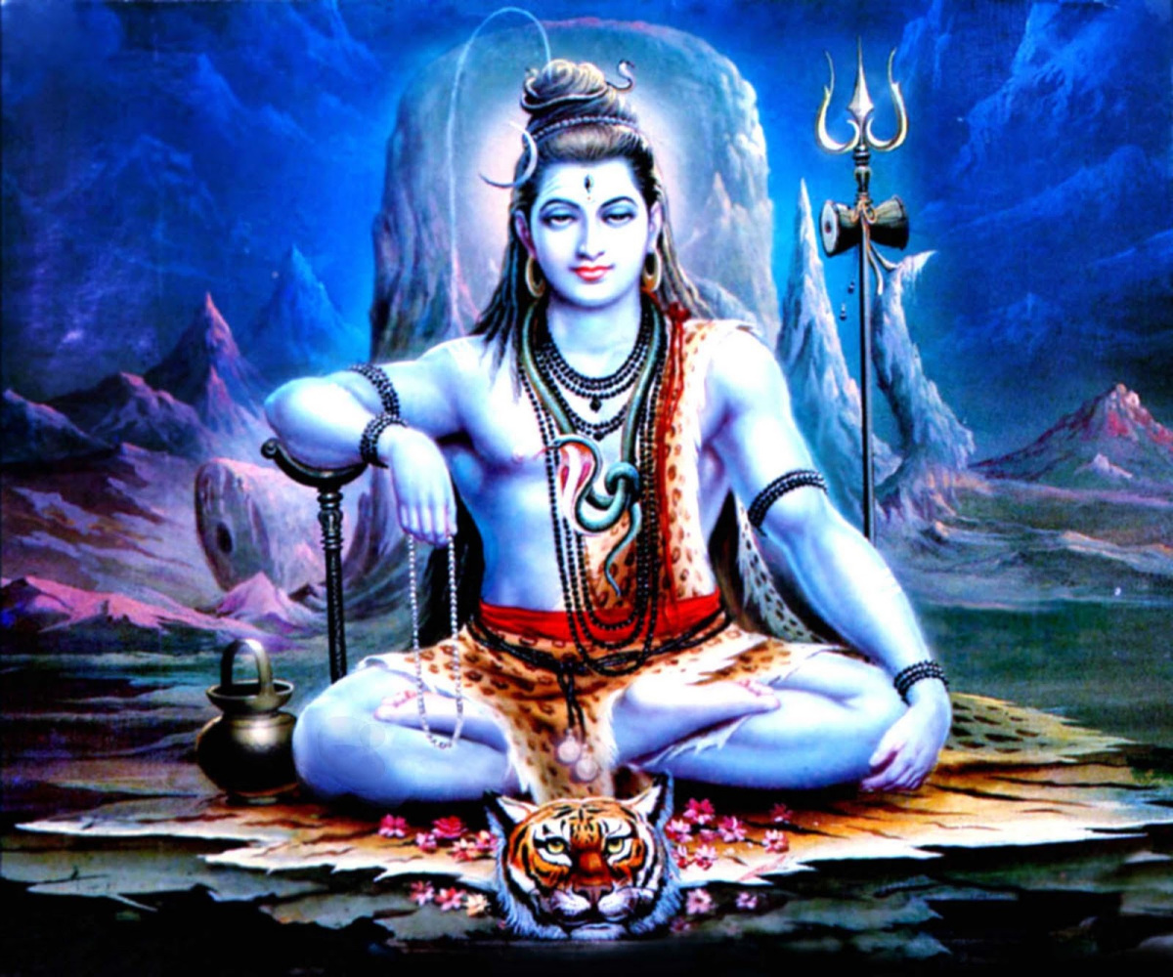

Water coming out from his head

He is telling u- Get in touch with the water inside you.

This simple exercise can balance yr DNA.

Do this exercise.

We ask Brother Kepler, work with this and give us yr feedback after 1 month working with the water, holding the water in yr mouth for 30 to 60 secs. Then again take one more sip hold it for 30 to 60 secs. U dont have to do anything.

Naturally u will feel a balance coming into u. Let us know after a month.

Anyone can do too.

This is Isis,

Moon Spirit

and AA Gabrielle.