**Tools for Empowerment - Creating New Thoughts and Beliefs**

Dear All, A brilliant channeling which just now came. Check it out and after trying the exercises, please let me know how you feel about it?

Rae

Subject: **Tools for empowerment - Creating New Thoughts and Beliefs**

Channeled Message from Celestial Beings and Creator

In these times, one has the potential to shift/balance all aspects of one’s life.  If you look around, you will see great changes in all areas of life and in all countries. It may cause many to go into fear and anxiety.  But this is an opportunity also to shift many of the past timelines which are affecting you on a moment to moment basis.  Then the question arises - how do you this?

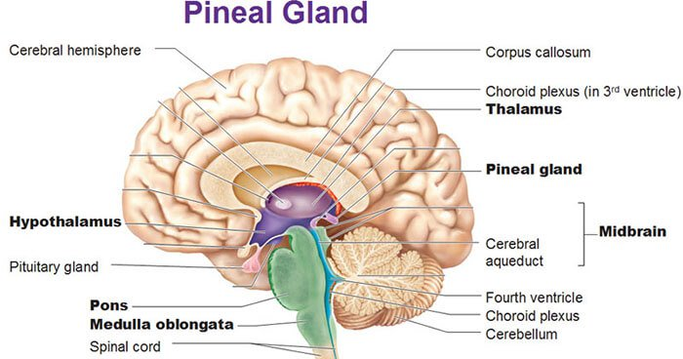

In the Pineal gland, there is a nerve center called NURONE which is connected to all past timelines and all past experiences.  This nerve center acts as light circuit whenever you have any thoughts on any of the experiences you have in your life.  E.g. if you have a thought about money, then this nerve center will in a nano second kick in and all the past experiences you ever had about money and all the thoughts you ever had about money, will be ignited and it will send out a call/energy to all the cells in the body and then your body in conduction with the Mind, will generate energy for the manifestation of that reality.   Your beliefs about your life is fully in conjunction with the energy centered in this nerve center.  And as your belief about your life, you will manifest it in your reality.

Here is a simple tool to shift the energy in this Nerve Center.

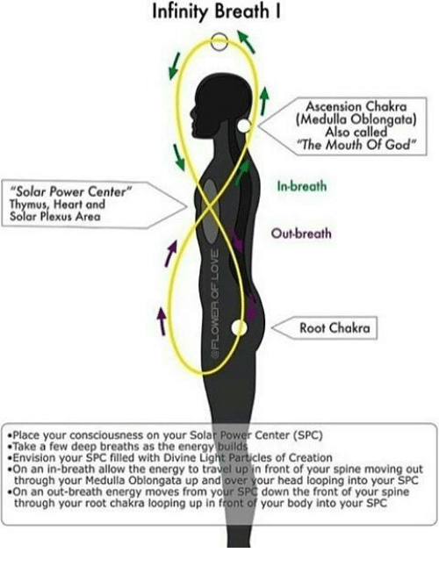

Bring your thumb of any hand and gently touch the medulla part of your head.  Nurone nerve center is in your medulla.  While gently touching, imagine a Three Point Star Golden Blue Color going from your thumb into your medulla.  Do this for a minimum of 3 minutes per sitting.  When the light start penetrating into the medulla, it will start to dilute the thought patterns which is deeply embedded in the Neuron and it will start to release the original encoded energy of Creation.  This Creation energy is in the form of a Golden Seed about 1/8th of an inch and this seed will start to sprout and you may visualize roots in golden color coming out of this seed and extending all the way down through your back into your tail bone area.  Breathing into this seed, will start to strengthen the roots and the roots will start to receive the original energy and this will go into the base chakra in which all the fear and belief about realities in the personality is held and which runs your life.

Do this for several days and after a while (about 16 days), bring your left thumb into the medulla and while gently touching that area, chant gently - raw-itt-omm for a minimum of 3 minutes and it will start to produce new chemicals in the Neuron nerve center and this in turn will help one to connect with the higher evolved star systems in our Solar Systems, and we will start to incorporate slowly those star systems belief systems about all things.

Welcome to the new world of Thought and Belief Creation Celestial Beings with Creator

Irhaan Rae Chandran

September 3, 2019